Q1.ATM Withdrawal
An ATM allows withdrawal only if the PIN is correct and the account balance is sufficient. Otherwise, display the appropriate error message.
- Use: if-else
- Test cases: Correct PIN and sufficient balance; incorrect PIN; insufficient balance.
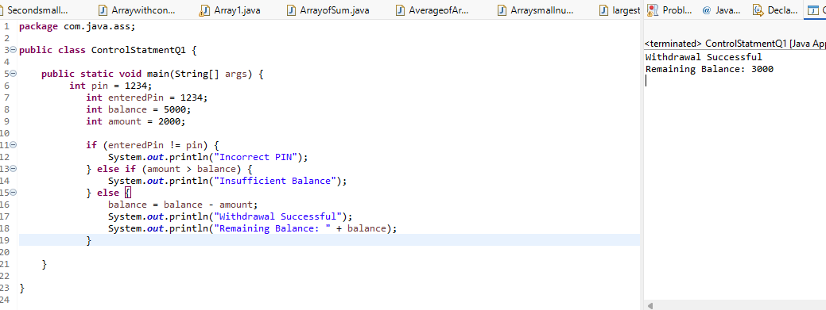
Q2. Electricity Bill Calculation
Calculate the electricity bill based on units consumed:
- First 100 units: ₹2 per unit
- Next 100 units: ₹3 per unit
- Above 200 units: ₹5 per unit
Use if-else to calculate the total bill.
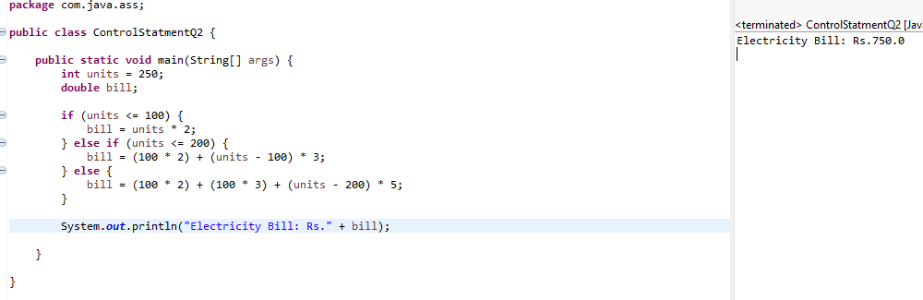
Q3. Student Grade System
Accept marks and display grades:
- 90–100: A
- 75–89: B
- 50–74: C
- Below 50: Fail
- Invalid marks: Display an error message.
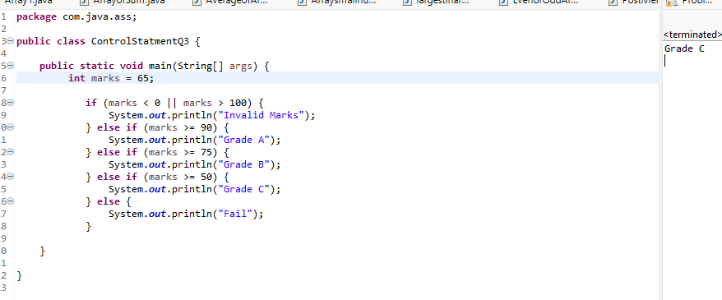
Q4. Login Attempt System
A user has three login attempts. If the password is correct, display “Login Successful” and stop the loop. Otherwise, display “Invalid Password.”
- Use: while and break
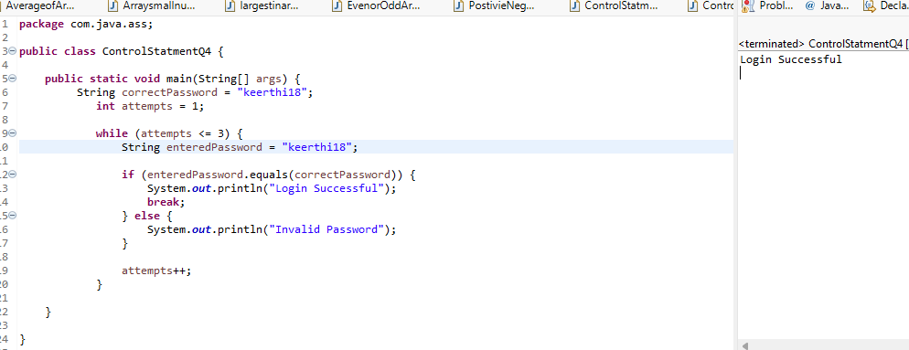
Q5. Skip Multiples of 3
Print numbers from 1 to 30, but skip all numbers divisible by 3.
- Use: for and continue
